**Week 9 Crisis of the Roman Republic (2)**

**Outline**

1. Taxation

(1) taxes raised on the basis of the census lists

(2) taxes where only the ratio was determined in advance (*vectigalia* and *portoria*)

1. *Tabula Heracleensis* (census lists)
2. *Publicani*; potentiality of abuse
3. Personal and civic patronage
4. Character of Roman expansion
5. Developments in Roman society from c. 150 BC
6. increase in number of Romans without property
7. concern about the number of recruits
8. Policies to relieve the problems
9. lowering threshold for military service (Marius, but not as revolutionary as sometimes claimed)
10. land distribution
11. Soldiers becoming loyal to their commanders
12. Social and political development from Marius to Augustus
13. Unconstitutional iteration of a magistracy.
14. Holding magistracies before the required age.
15. Bypassing of the senate by tribunes of the *plebs*.
16. Civil wars.
17. Unconstitutional offices.
18. Constitutional innovations or anomalies.
19. Cicero
20. Participant in the political affairs during the last years of the Republic.
21. Important source for the period from the 70s to 43 BC.
22. Political alliance between Pompey (Cn. Pompeius, cos. 70, 55, 52); Caesar (C. Iulius Caesar, cos. 59, 48, 46-44) and Crassus (M. Licinius Crassus, cos. 70, 55).

**Taxation**

The different taxes raised by the Roman state can be classified into the following 2 categories:

1. Taxes that were raised on the basis of the census lists (*tributa*; sing. *tributum*):
2. Explanation

Census lists were drafted by the censors, Roman magistrates (generally ex-consuls) who were elected from 443 BC onwards in the *comitia centuriata* once in 4(initially) or 5(later) years for 18 months—although in the first century BC there were extended periods without censors. Individuals had to give their full name, age, name of father (or *patronus*), domicile (living places), and the amount of their property. Censors then allocated citizens to tribes (*tribus*) and to centuries.

1. Sources: *Tabula Heracleensis*

A bronze tablet, by some scholars identified with a *lex Iulia municipalis* of 45 BC sponsored (not certain); at any rate, the text might have been of the Caesarian age.

<https://droitromain.univ-grenoble-alpes.fr/>

28) “Whoever has the chief magistracy or the supreme authority in those municipalities, colonies, or prefectures (*praefecturae*)of Roman citizens which exist in Italy at that time when the censor or some other magistrate takes the census at Rome shall take the census of the Roman citizens in all the aforesaid communities within sixty days after he knows that such census is being taken at Rome. He shaIl accept from them under oath their names, praenomens, parents or patrons, tribes, cognomens, the age of each citizen, and the statement of his property in accordance with(按照) the pattern of the census, which shall be posted(发布) at Rome by the official who is about to take the census of the people at that time. He shall enter all this on the public records of his municipality(自治市). He shall dispatch(发送) these registers to the censors at Rome by means of the envoys(代表，特使) chosen for this purpose by the majority vote of the senate when this matter is voted. He shall provide that the census shall be completed and that the envoys shall appear before the censors at Rome and shall deliver the registers of the respective municipalities, colonies, or prefectures more than sixty days before the census at Rome is completed. This censor, or whatever other magistrate conducts the census of the people in the next five days after the arrival of the envoys, shall accept without fraudulent intent(欺诈意图) the registers of the census from them. From these registers of the communities he shall provide that the entries shall be copied in the public records and that such records shall be filed in the same place where are filed the other public records containing the census of the people.

29) It is notthe intent of this law to require a person who has residence in several municipalities, colonies, or prefectures and who is entered in the census in Rome to be registered by this law in the census of the aforesaid communities as well.”

1. Taxes
   1. *Tributum capitis* (人头税，poll tax)
   2. *Tributum soli* (land tax)

Roman citizens did not pay tributa any more from 167 BC onwards (except in emergency).

* 1. *Stipendia*(sing. *stipendium*)

Tax for the upkeep of the army, primarily levied in newly acquired territories. *stipendia* were often regarded as harsh(苛刻的) tax.

1. Taxes where only the ratioto be paid was determined in advance: *vectigalia* (sing. *vectigal*) and *portoria* (关税，custom duties). Within the empire, the ratio of *portoria* may be lower.

Involved in the tax collection were quaestors, but also *publicani* (sing. *publicanus*) grouped together into companies leasing *tributa* during the period of the Republic and *vectigalia* during both Republic and Principate.

The exaction of taxes by *publicani* could lead to problems as the following decree of the *koinon* of Asia (passed in 71 BC) shows.

<https://insaph.kcl.ac.uk/insaph/iaph2007/iAph020503.html>

*IAph* 2.503 = J. Reynolds, *Aphrodisias and Rome* doc. 5:

[Decision of the koinon; proposal] of the presid ents and the secretary. Since, in view of the fact that the cities [and the nations are oppressed? everywhere] by the publicans and the [ . . . ? . . .] that have come into being, and [have been reduced] to the utmost (极度的) despair at the hands of some, the koinon of the Greeks met and unanimously (全体一致地) decided, [? at a special session] in the city of Ephesos, to send ambassadors to [the Senate and] magistrates, chosen from among men of the first rank and the most highly honoured, to [? report to them] concerning the aforesaid matters and the other [? affairs of the koinon] and to beg them to assist and [? protect] the province [which is being ruined]; and given that among the ambassadors chosen were [Dionysios and Hier]okles, sons of Jason the son of Skymnos, Aphrodisians, who also [exercised] citizenship in Tralles, who were not in residence [? there], the presidents sent a letter [about these men] to the people of Aphrodisias and about their selection [to go as ambassadors] for the common good of the Greeks, [among whom] they had a reputation for excellence and glory, as the detailed [testimonials (推荐信)] in the letter despatched on account of them make clear ; [and so], since the men, [who were present] and called upon by the People in the assembly which was summoned, [agreed] to carry out the embassy, and in its course endured many [and considerable] **dangers**, delivered the decrees [to the Senate] and magistrates, waited constantly, on every [occasion], on the magistrates, were involved in many serious contests [on behalf of] the koinon of the Greeks and were present at all of them, carried out their embassy with success and good fortune, in a manner worthy of the koinon of the Greeks and of [their] own reputation, and successfully secured the most important interests of [all] the peoples and nations [in Asia] ; for these reasons [it was agreed] by the koinon of [the Greeks] in Asia to decree praise to the aforesaid men and to crown each of them witha golden [crown] in consideration of their courage and zeal [and to set up] also bronze statues of them among whatever people or nation they wish, carrying the [inscription] ‘The peoples of Asia and the nations honoured for their excellence Dionysios and Hierokles [sons of Jason] the son of Skymnos who have successfully secured the most important matters '.

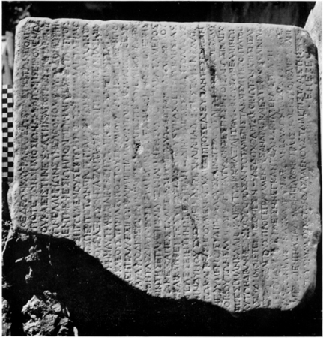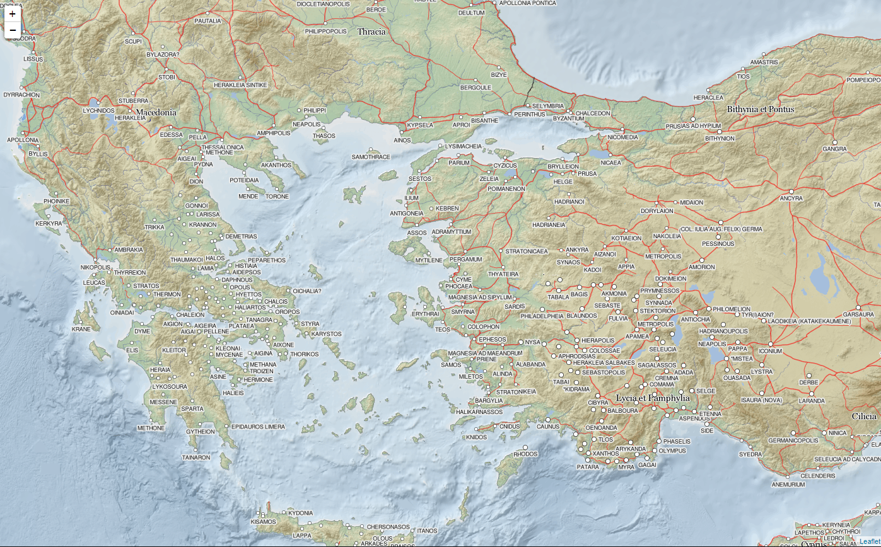

**Patronage (P82 – P83)**

Mainly 2 types: between individuals (personal) or communities (civic).

Example of civic patronage:

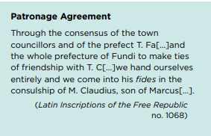[Consc]riptes co(n)se(nsu) T(iti) Fa[3 praefecti] / [et p]raifectura tot[a Fundi hospitium] / fecere quom Ti(berio) C[3] / [i]n eius fidem om[nes nos tradimus et] / co(n)venumis co[optamus eum patronum] / M(arco) Claudio M(arci) f(ilio) [3 co(n)s(ulibus)]

*Patronus & client*

*Patroni* were honored for the support and protection they had gave to their *clientes.* *Clientes* published many materials (inscriptions…) to memorize the support they gave and the feedback (thanks…) of their *patroni*. They were really proud of that.

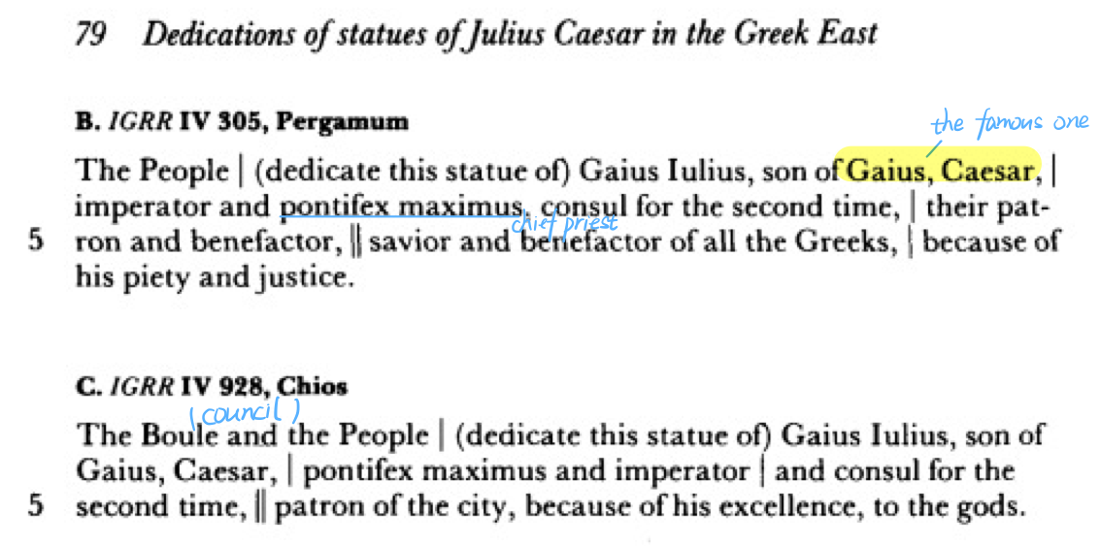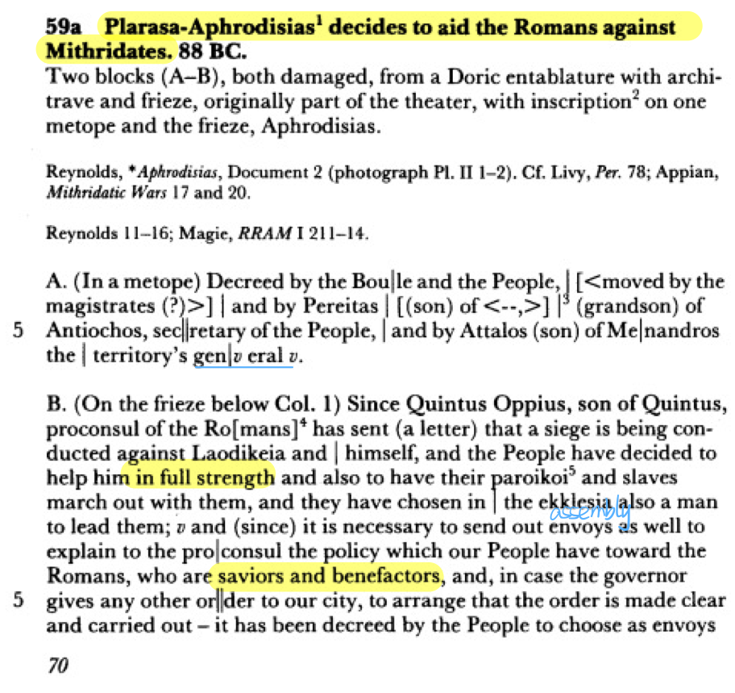

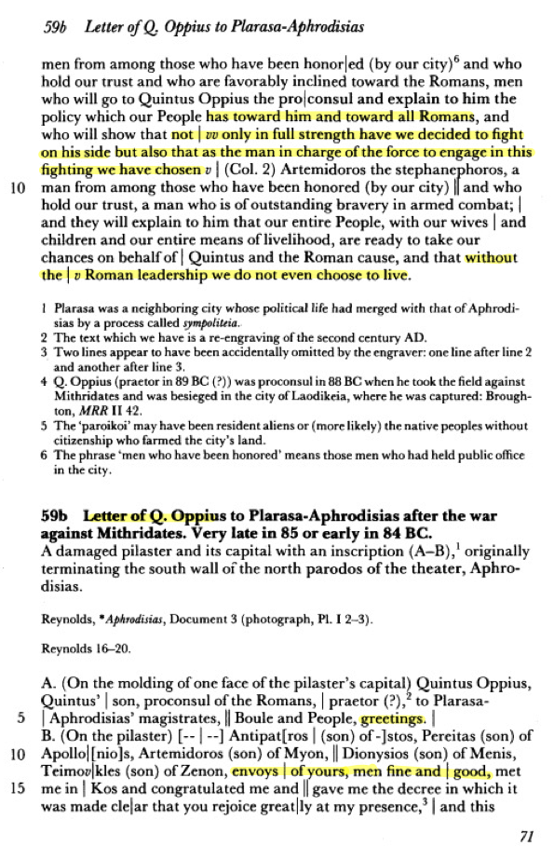

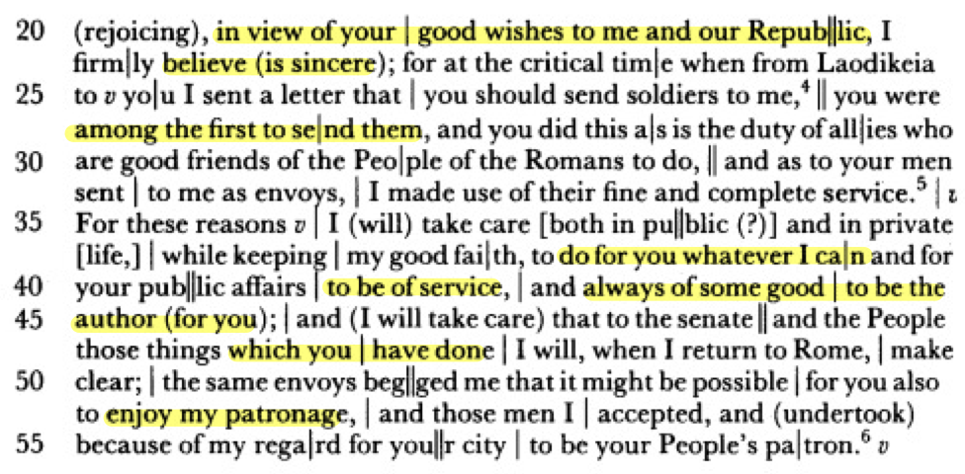

**Roman expansion in the Middle Republic (c. 270-129 BC)**

Scholarship has focused on the character (causes and pace) of Roman expansion. Defensive: Th. Mommsen, *The History of Rome*, English trans. (London 1877-1890); T. Frank, *Roman Imperialism* (New York [NY] 1914); M. Holleaux, *Rome, la Grèce et les monarchies hellénistiques au IIIe siècle avant* J.-C. (273-205) (Paris 1921): fear whether justified or not, unsought, not economic gain.

But, what about the high value attached to military accomplishments, and such institutions as the triumph? What about the almost continuous warfare and economic gains?

1. Offensive: W. V. Harris, *War and Imperialism in Republican Rome 327-70 BC* (Oxford 1979): aggressive, imperialistic, glory, economic benefits.

Problems to the second view: (a) relative quiet in 178-154 and after 133 BC; (b) decision-making process in the Senate.

1. ‘third way’: J. Rich, ‘Fear. Greed and glory: the causes of Roman war-making in the middle Republic’, in: J. Rich, G. Shipley (eds), *War and Society in the Roman World* (London 1993) 38-68.

**Roman Society Developments (Problems) from about 150 BC**

1. Increase in number of Romans without property; main causes:
2. Growth of large-scale landownership (debatable).
3. **Over-population** in Italy, although the Roman policy-makers seem to have thought that Italy’s population was decreasing, because of the difficulty in recruiting new soldiers (also, debatable).
4. Republican army until the first century BC was recruited only for the occasion of warfare (mostly confined to summer):
5. Roman citizens.
6. Property qualification (without property, no means to provide weapons).
7. Provision of own weapons.
8. Soldiers shared in the booty to some extent.

**Explanations: concern about the number of recruits.**

1. Roman policy-makers seem to have thought that a decrease in number of recruits occurred and that it was the result of a decrease in population and an increase in number of Roman citizens without property. The measures they took were aimed at countering these problems. The increase in the number of citizens without property will have played a role.
2. Yet, it should not be ignored that an important factor contributing to a decrease in the number of recruits seems to have been the reluctance of Roman citizens to be recruited for the dangerous and unprofitable wars in Spain waged intermittently from 154-133 BC. These citizens failed to register.

**Policies to relieve the problems of recruits.**

1. In first instance, lowering of the property threshold for serving in army.
2. Tiberius Gracchus in 133 BC as Tribune of the Plebs implemented policies to distribute land among the urban poor (proletariat) as a means to increase the number of recruits. With Appian’s *Civil Wars*, Plutarch’s biography of Tiberius Sempronius Gracchus can be reckoned (估计) among the most detailed accounts of the land reforms of this people’s tribune. The explanations provided by Plutarch for the social problems that triggered the land reforms are not entirely convincing. Tiberius’ policy was successful only temporarily.
3. C. Marius (156-86 BC) c. 100 BC reorganised the Roman army, abolished the property qualification, and made poor soldiers provided with weapons and with property after discharge from military service.

**Results**

As a possible result of these reforms of the army and the distribution of property to veterans (退伍军人), soldiers became loyal to their commanders, i.e., to the proconsuls and propraetors who were placed in command of Rome’s legions, instead of the Roman Republic. Promagistrates could use their armies to further their own ends. Conflicts among Rome’s elite were henceforth no longer only fought in the Senate and the People’s assemblies, but also on the battlefield.

**Social and political developments from Marius to Augustus**

The expansion of Rome’s empire, the social problems of the late second century and the solutions that were proposed to address those issues—in particular the inclusion of property-less citizens in the army as well as the provision of land to veterans (all of which aimed at tackling the decline in the number of recruits and the perceived increase in the number of proletarians(无产者)) led to an increase in competition among members of Rome’s governing elite, and to a growth in conflict. This dissension (纠纷) manifested (体现) itself in the following ways (although the precise relationship between these phenomena is difficult to determine):

1. Unconstitutionally long duration of a magistracy (e.g., the consulship by Marius in 107 and 104-100).
2. Holding magistracies before required age and before having served in minor magistracies (e.g. Cn. Pompeius – better known as Pompey the Great – was consul in 70 at the age of 36 instead of the required 42 years)
3. Bypassing of Senate by tribunes of the plebs (e.g., in 133 by Tiberius Sempronius Gracchus; in 67 by Aulus Gabinius). After Tiberius Gracchus, Roman politicians began to see the people’s tribunate as another source of power. Tribunes began to implement populist (平民派) policies (not necessarily on account of a supposed innate favour of middle and lower-class Roman citizens, but because they saw these policies as a means to gain political support that could facilitate their political agenda and advance their careers).
4. Civil Wars (e.g., in 88 BC between L. Cornelius Sulla (c. 138-78 BC) and C. Marius concerning the command over the war against the Pontic king Mithridates VI; in 83-82; in 49-44 and in 44-31 BC)
5. Unconstitutional offices (e.g., in 52 when Pompey held the consulship without colleague)
6. Dictatorships (e.g., Sulla in 82-81; Julius Caesar in the 40s BC)

**Some important figures of this time**

1. An important source of materials in this time: M. Tullius Cicero (106 – 43 BC)

**106** Birth Cicero into an equestrian (骑士) family.

Gratidia, M. Gratidius, M. Antonius (cos. 99), Helvia, C. Visellius Aculeo, L. Licinius Crassus (cos. 95), C. Visellius Varro. (?)

**90/89** Military service.

Q. Mucius Scaevola ‘Augur’ (cos. 117), Q. Mucius Scaevola ‘Pontifex’ (cos. 95, son of P. Mucius Scaevola, cos. 133). (?)

**81** Cicero’s defence of P. Quinctius (first case).

**79-77** Cicero studied in Athens and Rhodes.

**75** Quaestor in Sicily.

**70** Trial against C. Verres (*In Verrem*).

**66** Praetor; Cicero pleaded (承认) in favour of transferring command of the war against Mithridates VI to Pompey (*Pro lege Manilia*).

**63** Consul (*novus homo*) with C. Antonius ‘Hybrida’; conspiracy of L. Sergius Catilina; execution conspirators.

Q. Caecilius Metellus Celer (cos. 60) (?)

**60** Pact (条约) between C. Iulius Caesar (cos. 59, 48, 46-44), Cn. Pompeius (Pompey) (cos. 70, 55, 52) and M. Licinius Crassus (cos. 70, 55).

**59** Marriage between Pompey and Julia (Caesar’s daughter).

**58** Cicero exiled by law which P. Clodius Pulcher (tr. pl. of that year; hostile to Cicero since trial of 61) promulgated (颁布).

Bona Dea, Comitia curiata (?)

**57** Cicero recalled by law.

1. Cn. Pompeius (Pompey) (106-48 BC)
2. Political aims:
3. Ratification of eastern settlement.
4. Grants of land to his veterans.

But: opposition in the Senate:

1. Detailed examination.
2. Agrarian bill proposed, L. Flavius, a friendly tribune, rejected.
3. C. Julius Caesar (100-44 BC)
4. Political aims:
5. returning in c. June 60 from a propraetorship in Further Spain, Caesar requested a triumph, and hoped to win a consulship and subsequent provincial command.

But: opposition in the Senate:

1. No special dispensation to stand in absence; Caesar renounced his right to a triumph.
2. Senate decided that the consuls of 59 were to have *silvae callesque* (Suet. *Iul*. 19.1) as their provinces (the *lex Sempronia de provinciis consularibus* of 123 stipulated that the consular provinces should be determined prior to the elections, which usually took place in July).

**Results**

Pompey and Caesar forged a coalition: Caesar was elected as consul for 59; Pompey married Caesar’s daughter Julia.

1. M. Licinius Crassus (c. 112-53 BC)
2. Political aims:
3. Rebate of the sum owed by the *publicani* for their contract to collect the tithes of Asia
4. Check on Pompey

But: Rebate opposed by the Senate, especially Q. Caecilius Metellus Celer and M. Porcius Cato in 61.